A little
collection of

blog

helpsheets

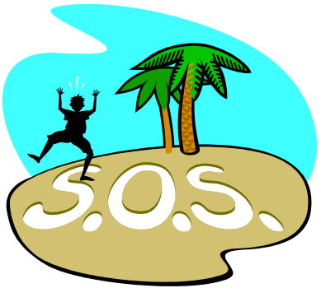

S. Blackburn 2010

Wanna be Blogtastic?

Starting off!

Go to https://www.blogger.com and click create a blog

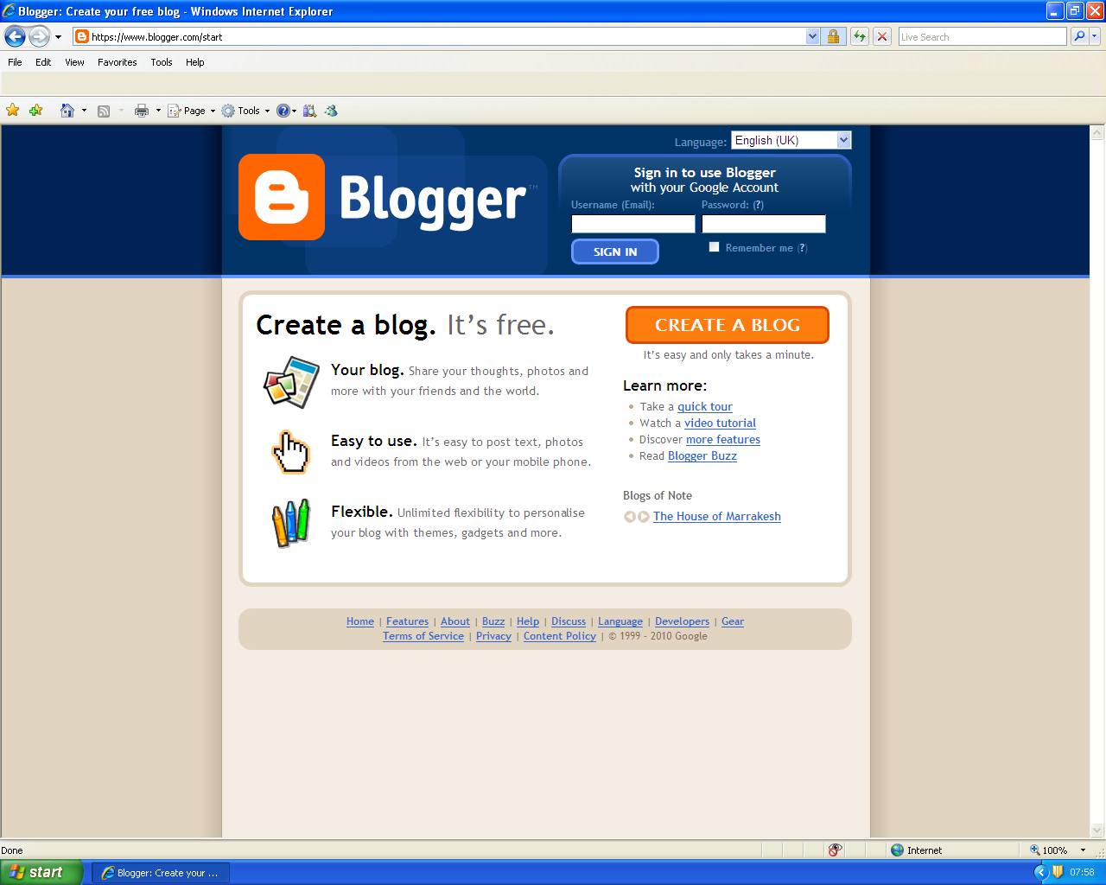

Fill in the details with your email account

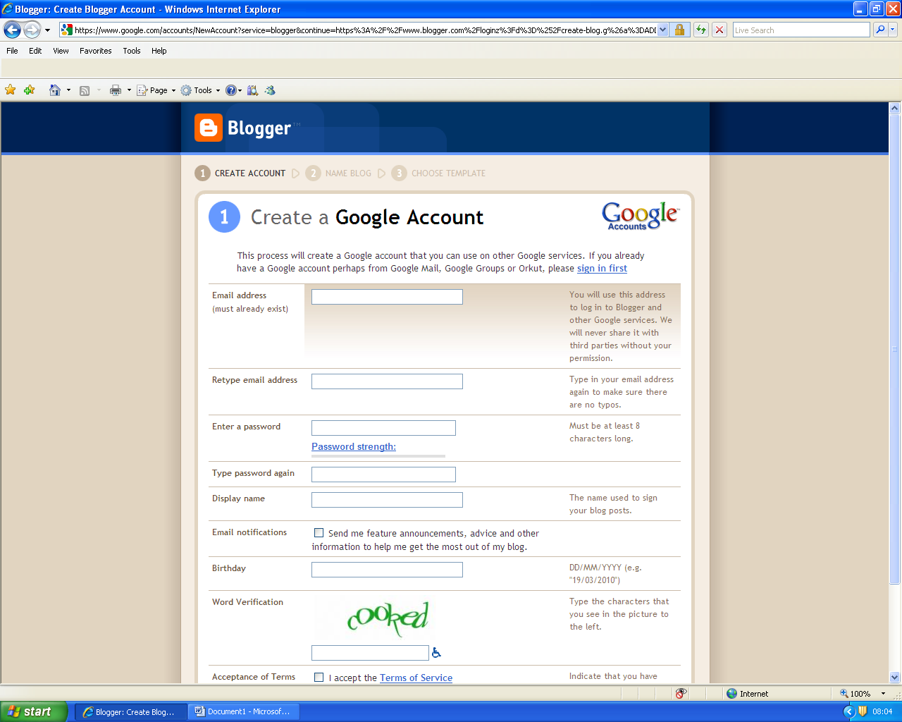

Then press continue

Once your account is created you should get this screen. The dashboard is the place where all your blogs are stored.

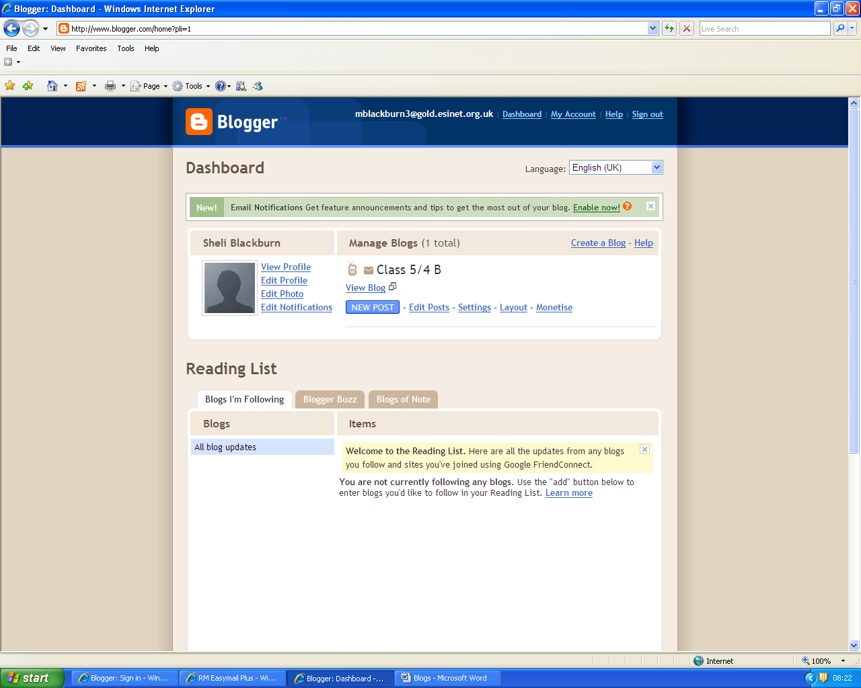

Each time you sign in to your account you will ‘land’ on your dashboard where you will see a list of all your blogs (I’ve got lots!) Blog is the name for a collection of posts on the same theme. For example, a sporting blog might have posts of all your schools sporting activities on it, or you may have one for a residential trip.

Each blog has its own unique web address (url). The blogs listed below on my dashboard might have between 2-20 different posts on each of them. A class page could have lots of different posts to show the range of work throughout the year.

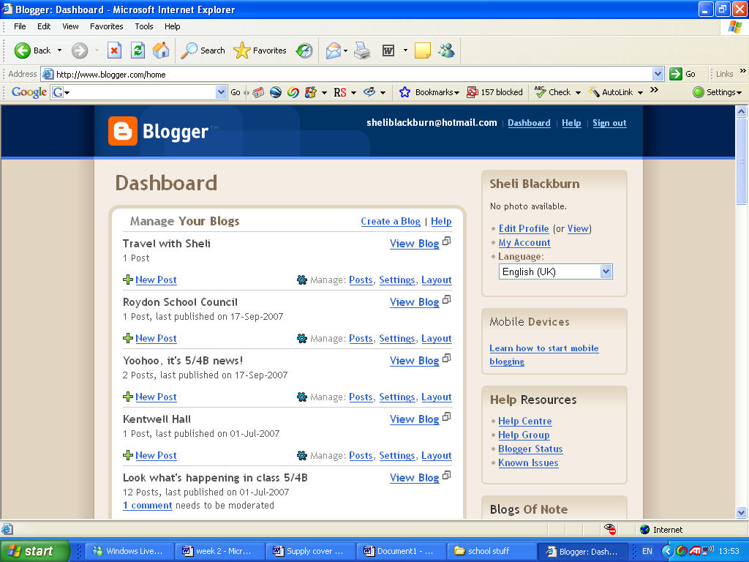

If you are creating a class page, you will probably want to
create a new blog each year.

When you log in for the first time it may go to straight to create post (page 4). Each subsequent time you log in it will take you to your dash board.

At the top of your dashboard it says Create a Blog | Help

click on create a blog, and this will appear.

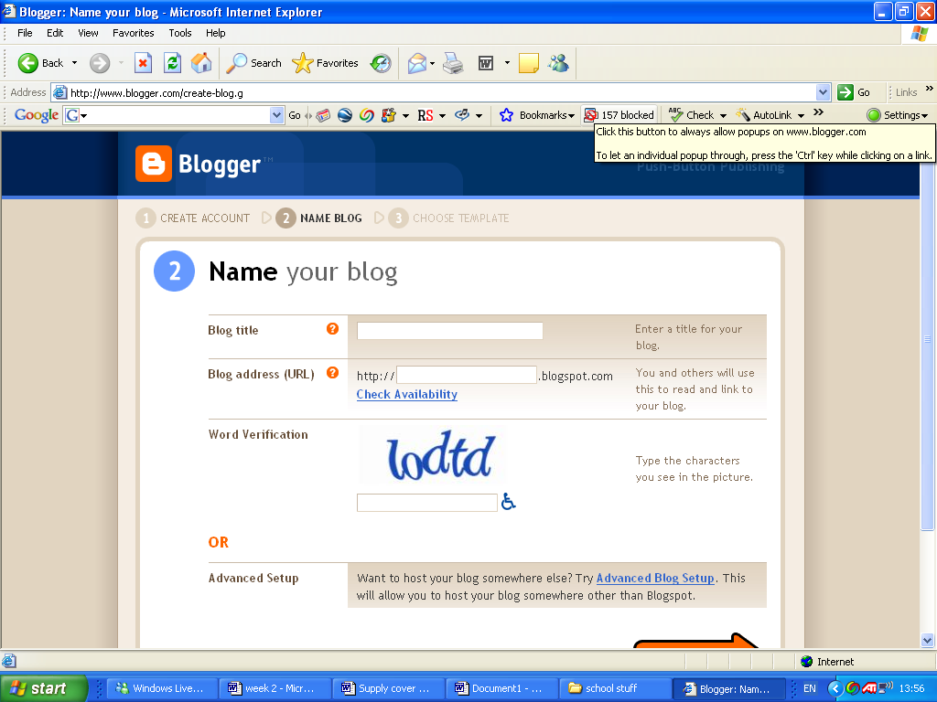

All you need to do is think of a name for the url for this year, then you can set up your class blog. Next year you will need to think of a new url for your class bog. For example, mine have been:

http://fab54b.blogspot.com/

http://54b2008.blogspot.com/

http://54b2007.blogspot.com/

http://lookwhatshappeninginclass54b.blogspot.com/

On the next screen you have to select a template. Choose any, but you will need to change your html settings if you want to prevent the ‘next blog’ button appearing. This makes it much safer, as you never know what the next blog might be! To do this, use the help sheet:

How to hide the blogger navbar (page 6)
Creating a new post

Once you have clicked on the new post button, you will see this page. The settings work very much like Microsoft word. It is easier to put all your pictures in before you write anything, as putting them in afterwards shifts the words around annoyingly! 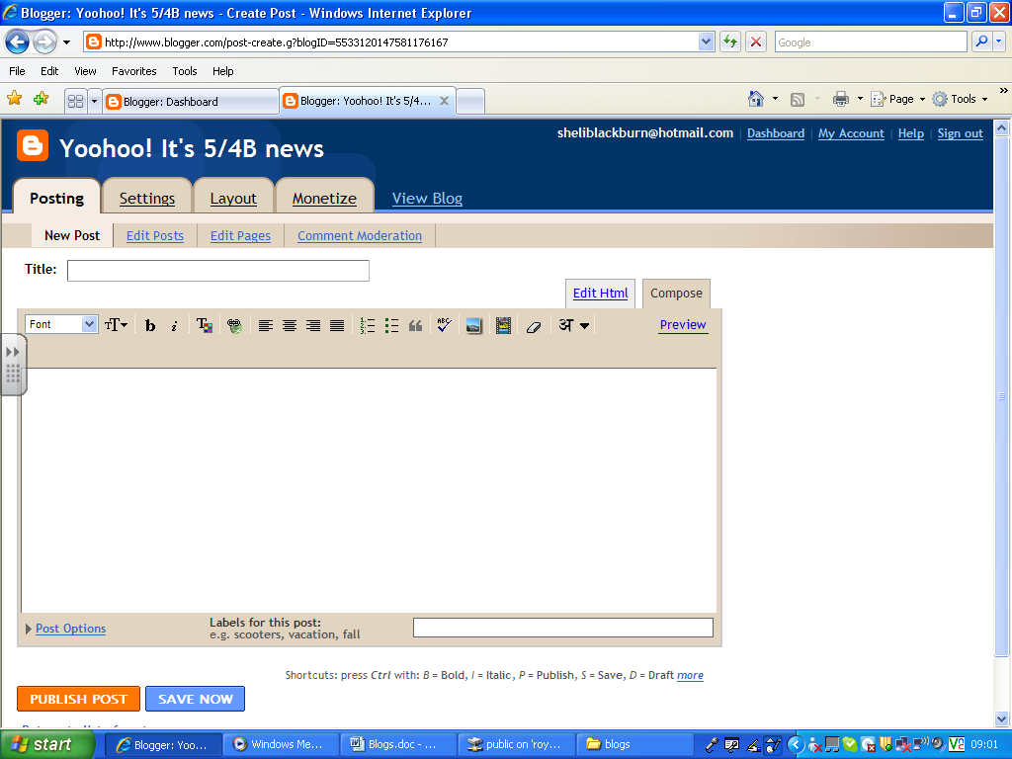

Upload your photos here. You will get the box below. It will ask you where to browse for your pics on your computer. You can experiment with size and position.

You can upload films here. They do take longer than photos though.

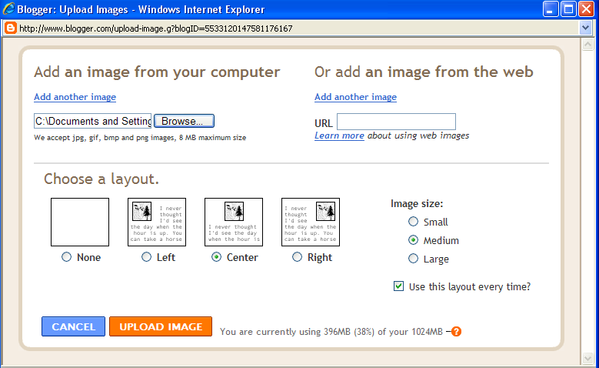
You can upload up to 5 images at a time by pressing Add another image

Tips:

- If you choose ‘none’ under layout, you can move pictures around easily and put two small ones next to one another
- If your pictures are taking forever to load, they may need compressing (see other sheet)

You can save your blog as a draft at any time (it will also automatically save it for you). When you are happy with it, you can publish it to the web. Be aware that they do look slightly different when they are published, so you may have to go back and play around with the layout. It is a good idea to look at other people’s blogs to see what looks good.

Changing your posts.

If you want to edit your posts, click on the edit posts tab and the list of your blogs will appear.

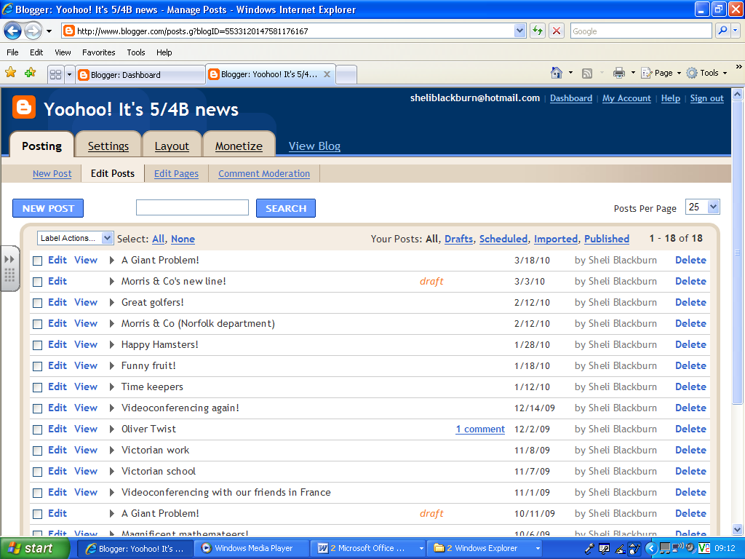

Click on the edit button for the post you want to edit, or click new post if you want to create a new one. You can add words, photos or films at any point.

Any comments will appear underneath the post.

Sparkly bits

You can add personal touches to your blog by clicking under layout. Experiment with adding gadgets on the side of your post, like the animation here http://fab54b.blogspot.com/. This was added as a picture.

You can also change heading colours etc under the fonts and colours tab


How to hide the Blogger Navbar :
Log in to blogger
On your Dashboard, select Layout. This will take you to the Template tab. Click Edit HTML. Under the Edit Template section you will see you blog's HTML.
Paste this CSS definition

#navbar-iframe {
display: none !important;
}

in the top of the template code between the grey highlighted parts:
<b:skin><![CDATA[/*
-----------------------------------------------
Blogger Template Style
Name: Rounders
Designer: Douglas Bowman
URL: www.stopdesign.com
Date: 27 Feb 2004
Updated by: Blogger Team
----------------------------------------------- */
#navbar-iframe {
display: none !important;
}
/* Variable definitions
====================
<Variable name="mainBgColor" description="Main Background Color"
type="color" default="#fff" value="#ffffff">
<Variable name="mainTextColor" description="Text Color" type="color"
default="#333" value="#333333">

Then click the save template button

Remove the code if you want to show it again.

Comment moderation

It is important to change the settings so that you can moderate your comments. To do this, go to your dashboard and click on edit posts. To change the comment moderation settings, click the settings tab, then the comments link. Follow the multiple choice questions down the page. The important one is to click ‘always’ next to comment moderation. Then make sure you save settings at the bottom of the page.

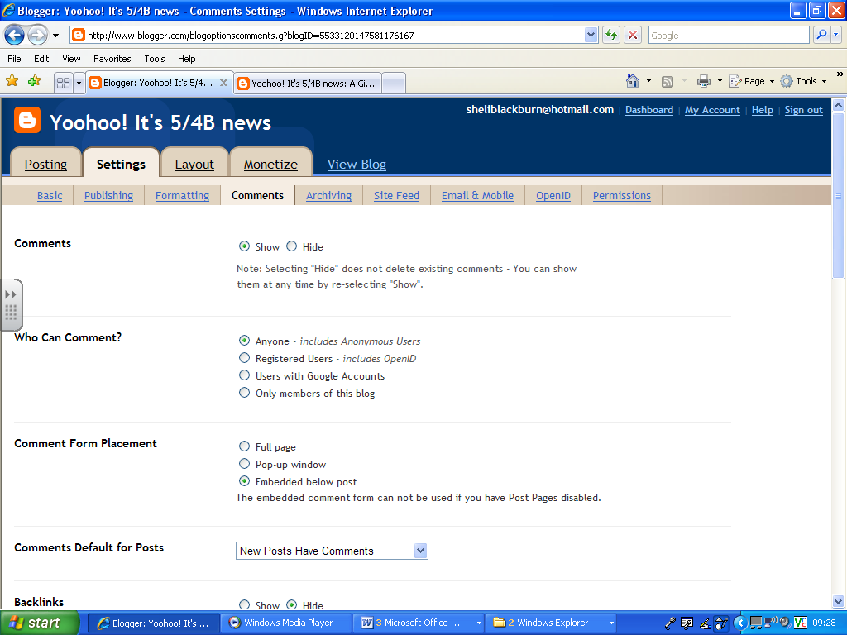

Tip: You can either set it up so that you receive emails about comments to moderate, or you can moderate them through the page above, by clicking onto the Posting tab, then commentsmoderation. You will know when you have comments to moderate, because it will say on your dashboard, underneath your blog. It will also tell you on your ‘edit posts’ page.

More tips

You can stay signed into your account on the google homepage by clicking on settings in the toolbar at the top of the google page, then google account settings

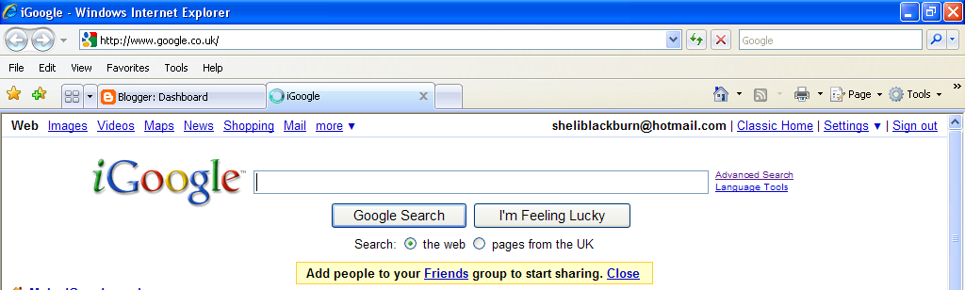

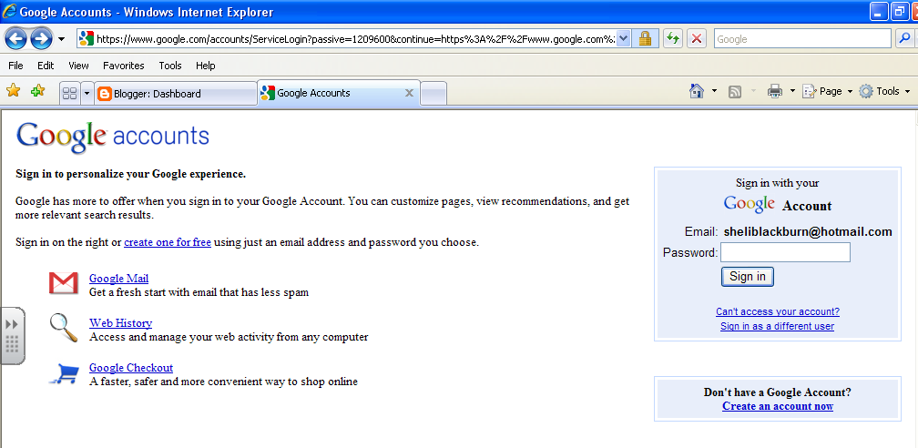
Sign in here

Your blogger account is located on the next page. If you use analytics, you can see how many people access your blog – and where in the world they are!



